**[04-IterationControlStructures](https://www.rajalakshmicolleges.net/moodle/course/view.php?id=84&section-4)**

**Ex.No. : 4.1 Date:**

**RegisterNo.: 231501070 Name: Kaaleeswaran v**

## [Factorsofanumber](https://www.rajalakshmicolleges.net/moodle/mod/quiz/view.php?id=5720)

Determine the factors of a number (i.e., all positive integer values that evenly divideintoanumber).

**Forexample:**

|  |  |  |
| --- | --- | --- |
| **Input** | **Result** |  |
| 20 | 124510  20 |  |

# Program:

k=int(input())l=[]

foriinrange(1,k+1):if(k%i==0):

l.append(i)forjinl:

print(j,end='')

# Output:

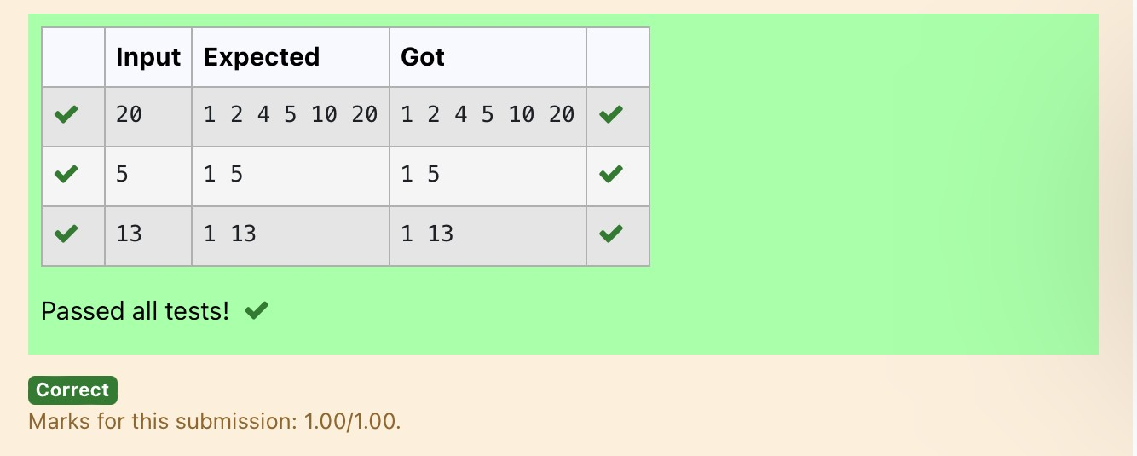

**Ex.No. : 4.2 Date:**

**RegisterNo.: Name:**

## [Non](https://www.rajalakshmicolleges.net/moodle/mod/quiz/view.php?id=5717)RepeatedDigitCount

Writeaprogramtofindthecountofnon-repeateddigitsinagivennumberN.Thenumberwillbepassedtotheprogramasaninputoftypeint.

Assumption:Theinputnumberwillbeapositiveintegernumber>=1and<=25000.Someexamplesareasbelow.

Ifthegivennumberis292,theprogramshouldreturn1becausethereisonly1non-repeateddigit'9'inthisnumber

Ifthegiven numberis1015,theprogram should return2because thereare2 non-repeateddigitsinthisnumber,'0',and'5'.

Ifthegivennumberis108,theprogramshouldreturn3becausethereare3non-repeateddigitsinthisnumber,'1','0',and'8'.

Ifthegivennumberis22,thefunctionshouldreturn0becausethereareNOnon-repeateddigitsinthisnumber.

**Forexample:**

|  |  |
| --- | --- |
| **Input** | **Result** |
| 292 | 1 |
| 1015 | 2 |
| 108 | 3 |
| 22 | 0 |

# Program:

n=int(input())l=[]

k=[]

whilen>0:a=n%10n=n//10l.append(a)

foriin range(len(l)):ifl.count(l[i])==1:

k.append(l[i])

print(len(k))

# Output:

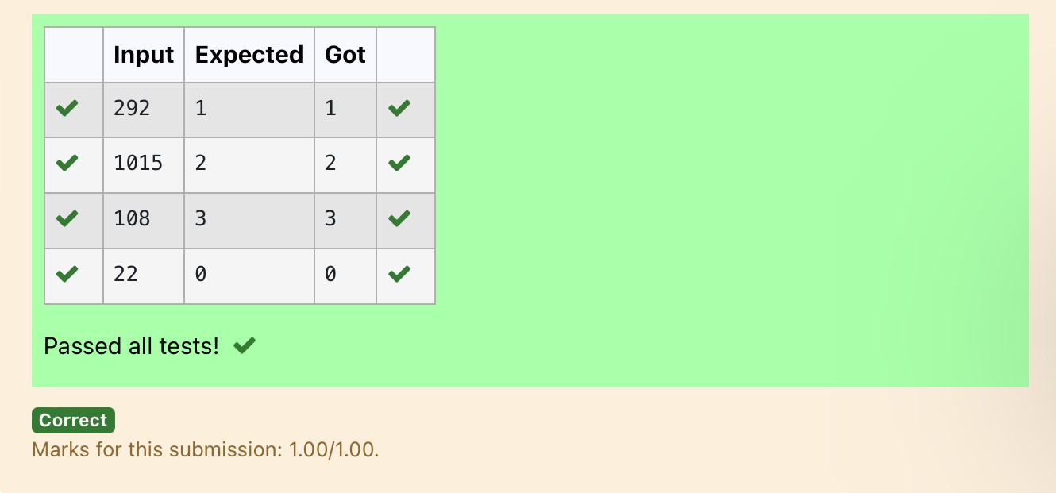

**Ex.No. : 4.3 Date:**

**RegisterNo.: Name:**

## PrimeChecking

WriteaprogramthatfindswhetherthegivennumberNisPrimeornot.Ifthenumberisprime,theprogramshouldreturn2elseitmustreturn1.

Assumption:2<=N<=5000,whereNisthe givennumber.Example1: if the given number N is 7, the method must return 2Example2:ifthegivennumberNis10,themethodmustreturn1

**Forexample:**

|  |  |
| --- | --- |
| **Input** | **Result** |
| 7 | 2 |
| 10 | 1 |

# Program:

a=int(input())

foriinrange(2,a):if(a%2==0):

flag=0elif(a%i!=0):flag=1

else:

flag=0if(flag==1):

print("2")elif(flag==0):

print("1")

# Output:

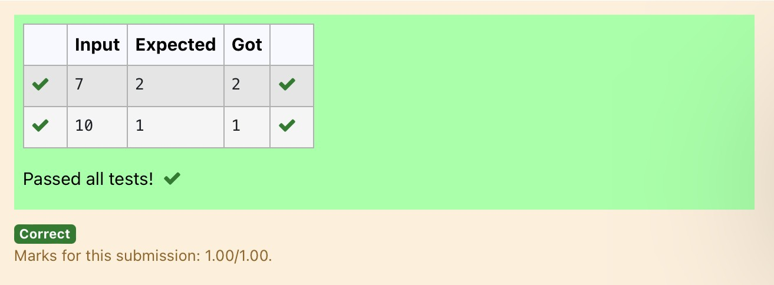

**Ex.No. : 4.4 Date:**

**RegisterNo.: Name:**

## NextPerfectSquare

GivenanumberN,findthenextperfectsquaregreaterthanN.InputFormat:

Integerinputfromstdin.OutputFormat:

PerfectsquaregreaterthanN.ExampleInput:

10

Output:

16

# Program:

a=int(input())c=[]

foriinrange(0,a):b=i**2

if(b>a):

c.append(b)print(c[0])

# Output:

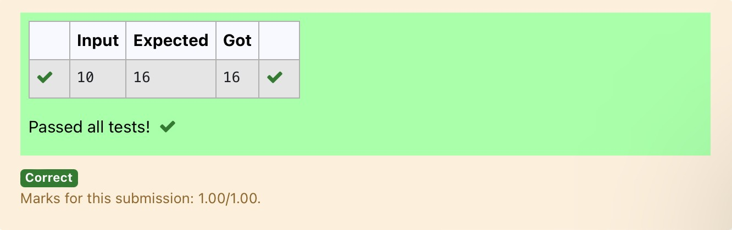

**Ex.No. : 4.5 Date:**

**RegisterNo.: Name:**

## NthFibonacci

Writea[program](https://www.rajalakshmicolleges.net/moodle/mod/quiz/view.php?id=3478)toreturnthenthnumberinthefibonacciseries.ThevalueofNwillbepassedtothe[program](https://www.rajalakshmicolleges.net/moodle/mod/quiz/view.php?id=3478)asinput.

NOTE:Fibonacciserieslookslike–

0,1,1,2,3,5,8,13,21,34,55,...andsoon.

i.e.Fibonacciseriesstartswith0and1,andcontinuesgeneratingthenextnumberasthesumoftheprevioustwonumbers.

* firstFibonaccinumberis0,
* secondFibonaccinumberis1,
* thirdFibonaccinumberis1,
* fourthFibonaccinumberis2,
* fifthFibonaccinumberis3,
* sixthFibonaccinumberis5,
* seventhFibonaccinumberis8,andsoon.

**Forexample:**

**Input:**

**7**

**Output8**

# Program:

a=[0,1]

foriinrange(0,100):a.append(a[-1]+a[-2])

q=int(input())print(a[q-1])

# Output:

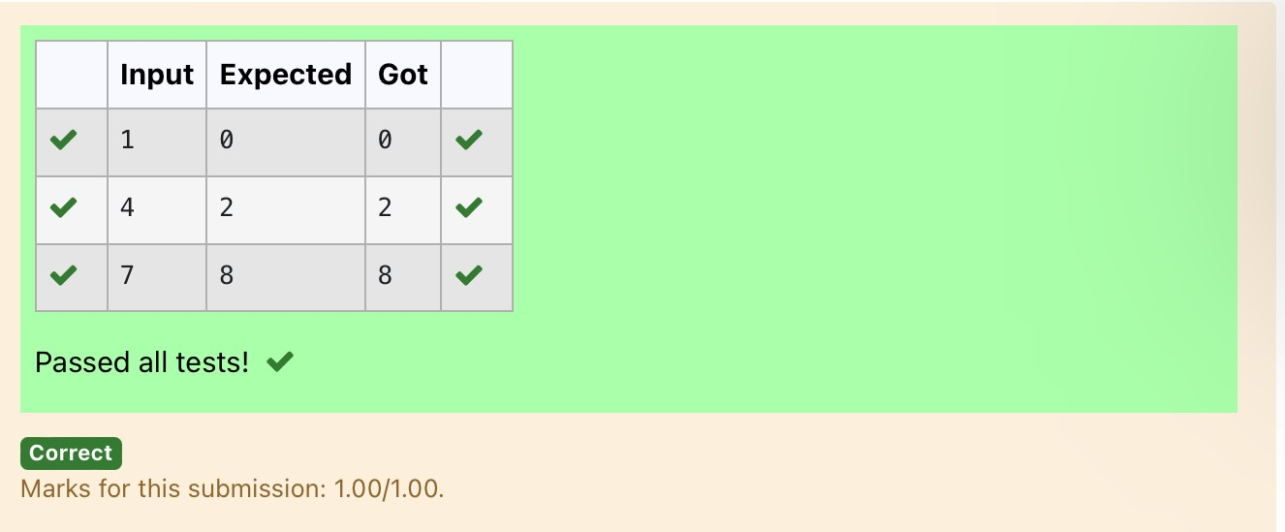

**Ex.No. : 4.6 Date:**

**RegisterNo.: Name:**

## DisariumNumber

A Number is said to be Disarium number when the sum of its digit raised to the powerof their respective positions becomes equal to the number itself. Write a [program](https://www.rajalakshmicolleges.net/moodle/mod/quiz/view.php?id=3478) toprintnumberisDisariumornot.

InputFormat:

SingleIntegerInputfromstdin.OutputFormat:

YesorNo.

ExampleInput:

175

Output:

YesExplanation

1^1+7^2+5^3=175

ExampleInput:123

Output:

No

**Forexample:**

|  |  |
| --- | --- |
| **Input** | **Result** |
| 175 | Yes |
| 123 | No |

importmath

# Program:

n=int(input())a=len(str(n))sum=0

x=nwhile(x!=0):

r=x%10sum=int(sum+math.pow(r,a))a-=1

x=x//10if(sum==n):

print("Yes")else:

print("No")

# Output:

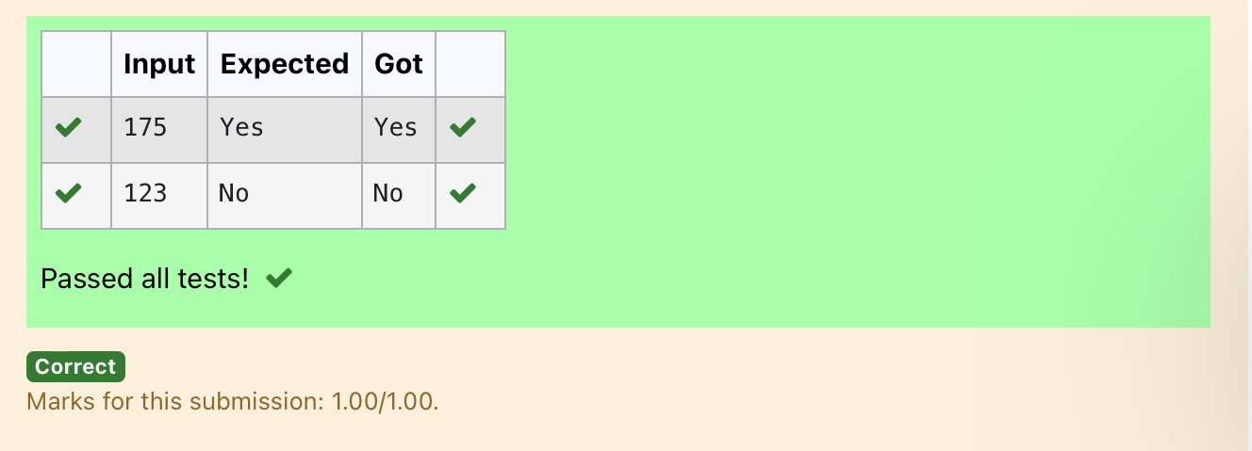

**Ex.No. : 4.7 Date:**

**RegisterNo.: Name:**

## SumofSeries

Writeaprogramtofindthesumoftheseries1+11+111+1111+...+nterms(nwillbegivenasinputfromtheuserandsumwillbetheoutput)

SampleTestCasesTestCase1

Input4

Output1234

Explanation:

asinputis4,havetotake4 terms.1+11+111+1111

TestCase2Input

6

Output123456

**Forexample:**

|  |  |
| --- | --- |
| **Input** | **Result** |
| 3 | 123 |

# Program:

n=int(input())b=1

sum=0

foriinrange(1,n+1):

sum+=bb=(b*10)+1

print(sum)

# Output:

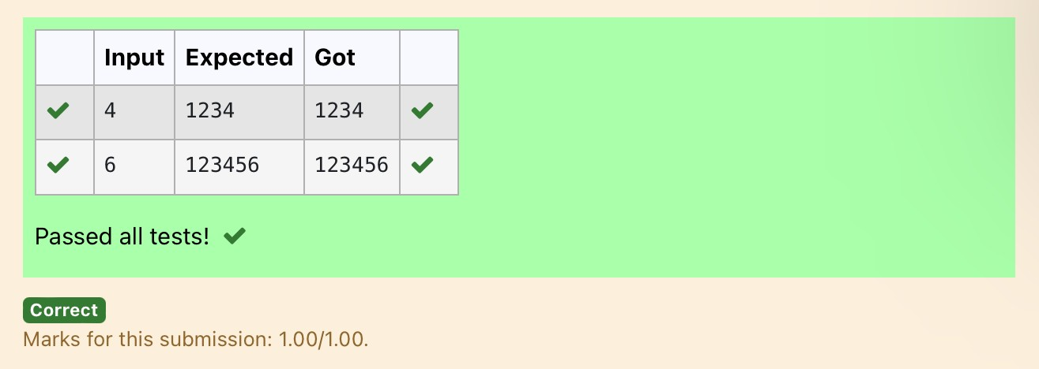

**Ex.No. : 4.8 Date:**

**RegisterNo.: Name:**

## UniqueDigitCount

WriteaprogramtofindthecountofuniquedigitsinagivennumberN.Thenumberwillbepassedtotheprogramasaninputoftypeint.

Assumption:Theinputnumberwillbeapositiveintegernumber>=1and<=25000.Fore.g.

Ifthegivennumberis292,theprogramshouldreturn2becausethereareonly2uniquedigits'2'and'9'inthisnumber

Ifthegivennumberis1015,theprogramshouldreturn3becausethereare3uniquedigitsinthisnumber,'1','0',and'5'.

**Forexample:**

|  |  |
| --- | --- |
| **Input** | **Result** |
| 292 | 2 |
| 1015 | 3 |

# Program:

a=int(input())b=[]

whilea>0:c=a%10a=a//10b.append(c)

b=list(set(b))print(len(b))

# Output:

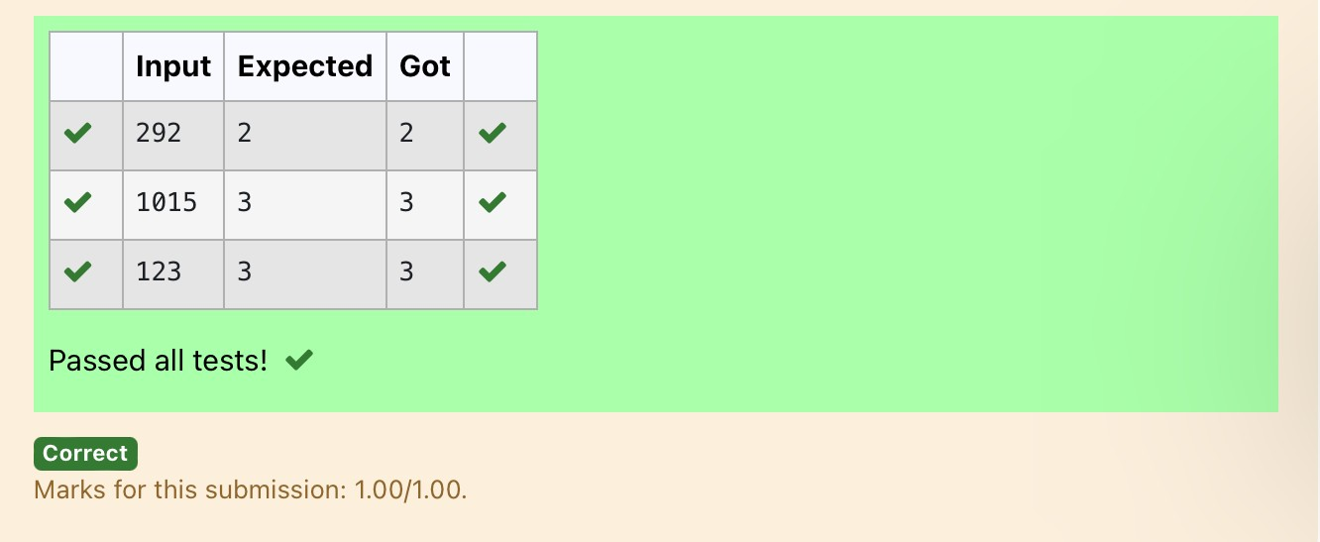

**Ex.No. : 4.9 Date:**

**RegisterNo.: Name:**

## Productofsingledigit

GivenapositiveintegerN,checkwhetheritcanberepresentedasaproductofsingledigitnumbers.

InputFormat:

SingleIntegerinput.

OutputFormat:

Output displays Yes if condition satisfies else prints No.ExampleInput:

14

Output:

Yes

ExampleInput:13

Output:

No

# Program:

a=int(input())flag=0

foriinrange(10):forjin range(10):

if(i*j==a):flag=1break

if(flag==1):print("Yes")

else:

print("No")

# Output:

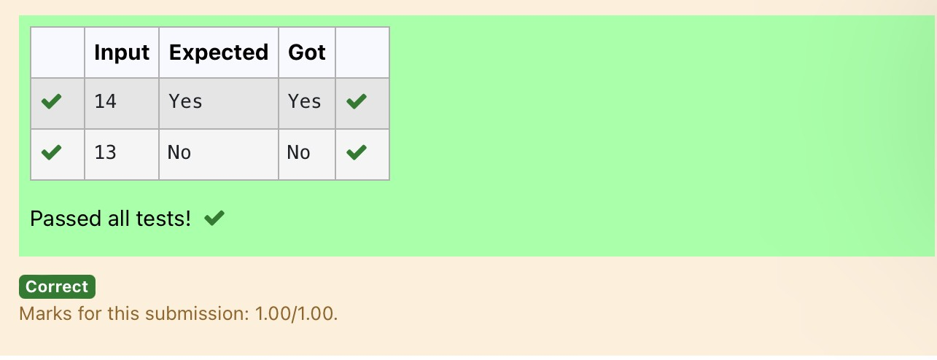

**Ex.No. : 4.10 Date:**

**RegisterNo.: Name:**

## PerfectSquareAfteraddingOne

GivenanintegerN,checkwhetherNthegivennumbercanbemadeaperfectsquareafteradding1toit.

Input Format:Singleintegerinput.OutputFormat:

YesorNo.

ExampleInput:

24

Output:

Yes

ExampleInput:26

Output:

No

**Forexample:**

|  |  |
| --- | --- |
| **Input** | **Result** |
| 24 | Yes |

# Program:

importmathn=int(input())a=n+1sr=int(math.sqrt(a))

if(sr*sr==a):print("Yes")

else:

print("No")

# Output:

